VLSI 1
Lab 3A Report: Synchronous Serial Port Design

Name : Anurag Banerjee

Course : EE360R

Students Signature : Verified by(TA):

Demo Date : / /2011
(To be filled in by the TA)

Original Submission Date: / /2011

1) Simulation with the second testbench (ssp_test2.v) [Need to be checked by TA]
FIFOs function correctly [ yes]
Transmit Logic functions correctly [ yes ]
Receive Logic functions correctly [ yes ]
RX & TX interrupts function correctly [ yes ]
Entire system functions correctly [ mostly ]

2) Synthesis
- Are all the modules synthesizable (read in without errors)? [ yes]
- Original report: Area: 2176 Arrival Time: 1.06
- Area optimization run report: Area: 1996. Arrival Time: 1.17
- Timing optimization run report: Area: 2176 Arrival Time: 1.06

3) Check if the following are submitted
- READABLE Waveform printouts (With all main ports and all FIFO storage elements displayed)
- Waveform results of ssp_test2.v
b) printouts of all verilog files
c) Brief description on the strategy you used for your design
e) Synthesis report from initial, area optimization, and timing optimization
runs (3 reports).

4) Electronic Submission of verilog files

*Important: Please zoom in to your waveform properly. Unreadable data can cause serious disadvantages to your grade. All 8 FIFO locations should be visible in your waveforms both at demonstration and in your report.

Design Description:

My design centered around the specifications described within the document.

TXFIFO:The Tx Fifo would load in values according to the PCLK rising edge and some basic combinational logic using the other input signals into the SSP. A Fifo pointer register was used to keep track of the number of values currently in the FIFO and where to write to next.

Transfer Logic: The transfer logic would read in values from the FIFO as quickly as possible. The TX Pin was loaded on SSPCLK rising edges and was done until a counter register reached 8, signifying all bits had been successfully transmitted. The transfer load register was serially shifted in order to perform parallel to serial conversion.

Receive Logic: The receive logic would read in values on falling edges of FSSIN and put the transmitted data into the lsb of the Receive load register. This was serially shifted left 8 times using another 8 bit counter. After all shifts, the receive would flash a load ready signal for the RxFIFO to load in the contents of the receive load register.

RXFIFO: Worked largely the same as TxFifo

CODE:
module TOP(
PSEL,
PWRITE,
PWDATA,
PRDATA,
CLEAR_B,
PCLK);

parameter DATA_WIDTH = 8;

wire PSEL, PWRITE, CLEAR_B;
wire PCLK;
wire [DATA_WIDTH -1:0] PWDATA;
wire [DATA_WIDTH-1:0] TxDaty;
wire SSPTXINTR;
wire SSPTXEMPTY;
wire SSPOE_B;
wire SSPTXD;
wire SSPFSSOUT;
wire SSPCLKOUT;
wire ready;
wire SPOEB;
wire [DATA_WIDTH -1:0] PRDATA;
wire [DATA_WIDTH-1:0] RxData;
input PCLK;
input PWRITE;
input [DATA_WIDTH -1: 0] PWDATA;
input CLEAR_B;
input PSEL;

output [DATA_WIDTH -1 : 0] PRDATA;

/*

always begin
#3 PCLK = !PCLK;

end

initial
begin

PSEL = 1;
PWRITE = 0;
PWDATA = 8'hA7;
CLEAR_B = 1;
PCLK = 0;
#1
PWRITE = 1;
PWDATA = 8'hA4;
#6

PWRITE = 0;
PWDATA = 8'hB6;

#6

PWRITE = 1;
PWDATA = 8'hC7;
#6
PWRITE = 0;
PWDATA = 8'hF2;
CLEAR_B = 0;
#6

PWDATA = 8'h23;

end

// Run simulation for 15 ns.
initial #265 $finish;

// Dump all waveforms to d_latch.dump
initial
begin
$dumpfile ("ssptop.dump");
$dumpvars (0, TOP);
end // initial begin
*/
tlogic tloge(SSPOE_B,SSPTXD,SSPFSSOUT,SSPCLKOUT,PCLK,TxDaty,SSPTXEMPTY,ready,eightBity,loadReady,RxData);
txfifo tFife(PSEL, PWRITE, PWDATA, CLEAR_B, PCLK, TxDaty, SSPTXINTR, SSPTXEMPTY, ready,eightBity);

rxfifo rxfify(PSEL,PWRITE,PRDATA,CLEAR_B,PCLK,RxData,SSPRXINTR,SSPRXEMPTY,loadReady);

endmodule

module tlogic (
SSPOE_B,
SSPTXD,
SSPFSSOUT,
SSPCLKOUT,
PCLK,
TxData,
SSPTXEMPTY,
ready,
eightBity,
loadReady,
RxData);

parameter DATA_WIDTH = 8;

input PCLK;
input [DATA_WIDTH -1: 0] TxData;
input SSPTXEMPTY;

output SSPOE_B;
output SSPTXD;
output SSPFSSOUT;
output SSPCLKOUT;
output ready;
output eightBity;
output loadReady;
output [DATA_WIDTH -1: 0] RxData;

wire PCLK;
wire SSPTXEMPTY;

/*Output registers*/
reg SSPFSSOUT; //these might be regs. make sure later
reg SSPCLKOUT;
reg SSPTXD;
reg SSPOE_B;
reg ready;

/*Internal variables*/
reg [DATA_WIDTH -1 :0] TLRegister;
reg [DATA_WIDTH -1 :0] eightBitcounter;
assign eightBity = (eightBitcounter == 7);

initial begin
ready = 1;
SSPTXD =0;
SSPFSSOUT = 0;
SSPCLKOUT = 0;
TLRegister = 0;
eightBitcounter =0;
SSPOE_B = 1;
end

always @( posedge PCLK) begin: SSPCLK_logic
SSPCLKOUT <= !(SSPCLKOUT);
end

always @( SSPCLKOUT) begin: SPOE_b_logic
if(!SSPCLKOUT) begin
if(eightBitcounter == 0)begin
SSPOE_B <= 0;
end
else if (eightBitcounter == 7) begin
SSPOE_B <= 1;
end

end
end

always @( SSPCLKOUT) begin: eight_bit_counter
if(SSPCLKOUT) begin
if(!ready)begin
eightBitcounter <= eightBitcounter +1;
end else if(ready) begin
eightBitcounter <= 0;
end
end
end

always @(posedge PCLK) begin: ready_logic
if(SSPCLKOUT) begin
if(SSPFSSOUT)begin
ready <= 0;
end
else if(eightBitcounter == 7)begin
ready <= 1;
end
end
end

always @(SSPCLKOUT) begin: fssout_logic
if(SSPCLKOUT) begin
if((!SSPTXEMPTY) &&(ready))begin
SSPFSSOUT <= 1;
end
else begin
SSPFSSOUT <= 0;
end
end
end

always@(SSPCLKOUT) begin: TLReg_logic
if(SSPCLKOUT) begin
if((!SSPTXEMPTY) &&(ready))begin
TLRegister <= TxData;
end

if(!ready)begin
SSPTXD <= TLRegister[7];
TLRegister <= {TLRegister[6:0], 1'b0};
end

end
end

//now need to take care of SSPOE_B
rlogic rlogica(SSPCLKOUT,SSPFSSOUT,SSPTXD,loadReady,RxData);
endmodule

module txfifo (
PSEL,
PWRITE,
PWDATA,
CLEAR_B,
PCLK,
TxData,
SSPTXINTR,
SSPTXEMPTY,
ready,
bC);

parameter DATA_WIDTH = 8;
parameter FIFO_SIZE = 4;

//Input Variables
input PSEL;
input PWRITE;
input [DATA_WIDTH-1:0] PWDATA;
input CLEAR_B;
input PCLK;
input ready;
input bC;

//Output Variables
output [DATA_WIDTH -1:0] TxData;
output SSPTXINTR; //interrupt signal when full
output SSPTXEMPTY; // interrupt signal when empty
wire SSPTXINTR;
wire SSPTXEMPTY;
wire CLEAR_B;

// Internal Variables
reg [DATA_WIDTH -1:0] Tx1; //registers in FIFO. TXL is the thing that drives the output (TxData for logic operations in the Tranfer Logic block)
reg [DATA_WIDTH -1:0] Tx2;
reg [DATA_WIDTH -1:0] Tx3;
reg [DATA_WIDTH -1:0] Tx4;

reg [FIFO_SIZE -1 : 0] FIFOPOINTER;
reg [FIFO_SIZE -1 : 0] fifoCounter;
reg eightFlag;

assign SSPTXINTR = (FIFOPOINTER == FIFO_SIZE +1);
assign SSPTXEMPTY = (FIFOPOINTER == 1);

assign TxData = Tx1;

initial begin
FIFOPOINTER = 1;
Tx1 = 0;
Tx2 = 0;
Tx3 = 0;
Tx4 = 0;
end

always@(posedge PCLK) begin: eight_bito

if((bC ==1) &&(!eightFlag))begin
eightFlag <= 1;
end
else begin
eightFlag <=0;
end

end

always@(posedge PCLK)begin: update_pointer
if (!(CLEAR_B)) begin
FIFOPOINTER <=0;
Tx1 <= 0;
Tx2 <= 0;
Tx3 <= 0;
Tx4 <= 0;
end else if(eightFlag) begin
//(!SSPTXEMPTY)&&(ready)
FIFOPOINTER <= FIFOPOINTER -1;

Tx1 <= Tx2;
Tx2 <= Tx3;
Tx3 <= Tx4;
end else if( PSEL && PWRITE && (!SSPTXINTR)) begin
FIFOPOINTER <= FIFOPOINTER +1;
case(FIFOPOINTER)
1: Tx1 <= PWDATA;
2: Tx2 <= PWDATA;
3: Tx3 <= PWDATA;
4: Tx4 <= PWDATA;
endcase

end
end

endmodule

module rlogic (
SSPCLKIN,
SSPFSSIN,
SSPRXD,
loadReady,
RxL);

parameter DATA_WIDTH = 8;

input SSPCLKIN;
input SSPRXD;
input SSPFSSIN;

output loadReady;
output[DATA_WIDTH -1:0] RxL;

reg [DATA_WIDTH-1:0] RxL;
reg[DATA_WIDTH-1:0] eightCount;
reg shifty;
reg loadReady;

initial begin
RxL <= 0;
eightCount <=0;
end

always@(posedge SSPCLKIN)begin:counter_logic
if(SSPFSSIN)begin
eightCount <= 0;
shifty <= 1;
end
else if (eightCount == 7)begin
eightCount <=0;
shifty <=0;
end else if(shifty ==1) begin
eightCount <= eightCount +1;
end
end

always @(posedge SSPCLKIN)begin
if((shifty == 1) &&(eightCount ==7))begin
loadReady <= 1;
end
else begin
loadReady <= 0;
end
end

always@(posedge SSPCLKIN)begin:shift_reg_logic
RxL[7] <= RxL[6];
RxL[6] <= RxL[5];
RxL[5] <= RxL[4];
RxL[4] <= RxL[3];
RxL[3] <= RxL[2];
RxL[2] <= RxL[1];
RxL[1] <= RxL[0];
RxL[0] <= SSPRXD;
end

endmodule

module rxfifo (
PSEL,
PWRITE,
PRDATA,
CLEAR_B,
PCLK,
RxData,
SSPRXINTR,
SSPRXEMPTY,
loadReady);

parameter DATA_WIDTH = 8;
parameter FIFO_SIZE = 4;

//Input Variables
input PSEL;
input PWRITE;
input CLEAR_B;
input PCLK;
input [DATA_WIDTH -1:0] RxData;
input loadReady;

//Output Variables
output SSPRXINTR; //interrupt signal when full
output SSPRXEMPTY; // interrupt signal when empty
output [DATA_WIDTH-1:0] PRDATA;

wire SSPRXINTR;
wire SSPRXEMPTY;
wire CLEAR_B;

// Internal Variables
reg [DATA_WIDTH -1:0] Rx1; //registers in FIFO. TXL is the thing that drives the output (TxData for logic operations in the Tranfer Logic block)
reg [DATA_WIDTH -1:0] Rx2;
reg [DATA_WIDTH -1:0] Rx3;
reg [DATA_WIDTH -1:0] Rx4;

reg [FIFO_SIZE -1 : 0] FIFOPOINTER;

assign SSPRXINTR = (FIFOPOINTER == FIFO_SIZE +1);
assign SSPRXEMPTY = (FIFOPOINTER == 1);

assign PRDATA = Rx1;

initial begin
FIFOPOINTER = 1;
Rx1 = 0;
Rx2 = 0;
Rx3 = 0;
Rx4 = 0;
end

always@(posedge PCLK)begin: update_pointer
if (!(CLEAR_B)) begin
FIFOPOINTER <=0;
Rx1 <= 0;
Rx2 <= 0;
Rx3 <= 0;
Rx4 <= 0;
end else if(PSEL && (!PWRITE) &&(!SSPRXEMPTY)) begin
//(!SSPRXEMPTY)&&(ready)
FIFOPOINTER <= FIFOPOINTER -1;
Rx1 <= Rx2;
Rx2 <= Rx3;
Rx3 <= Rx4;
end else if(PSEL && (!SSPRXINTR) && loadReady) begin
FIFOPOINTER <= FIFOPOINTER +1;
case(FIFOPOINTER)
1: Rx1 <= RxData;
2: Rx2 <= RxData;
3: Rx3 <= RxData;
4: Rx4 <= RxData;
endcase
end
end

endmodule

WAVEFORMS:

Transmitter Results:
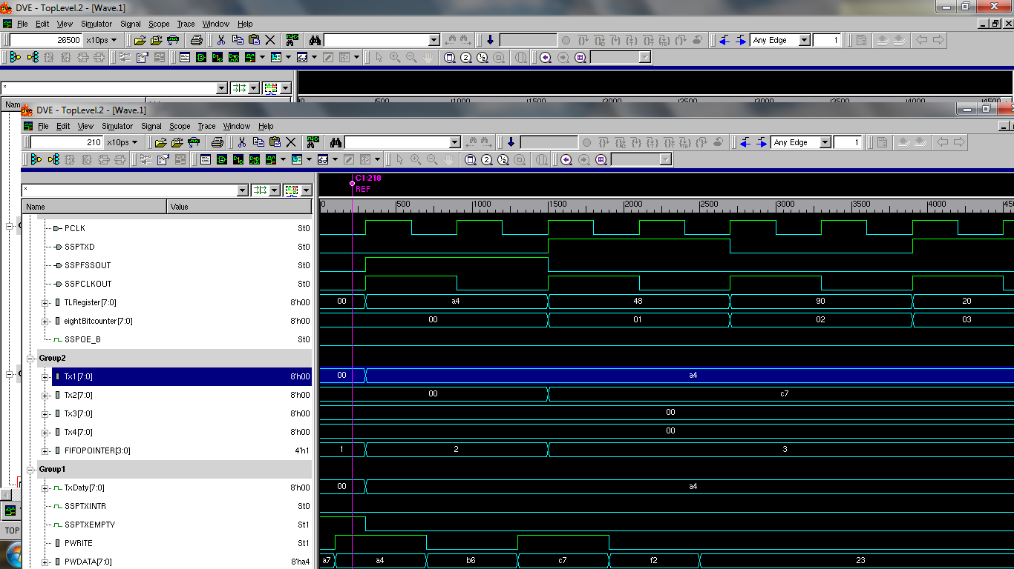
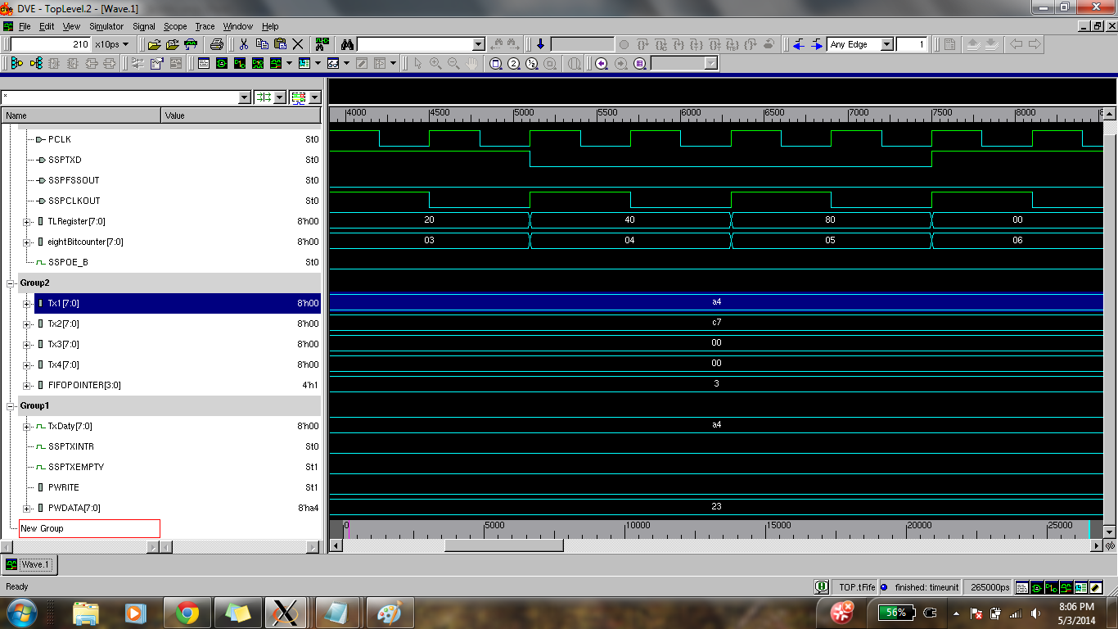

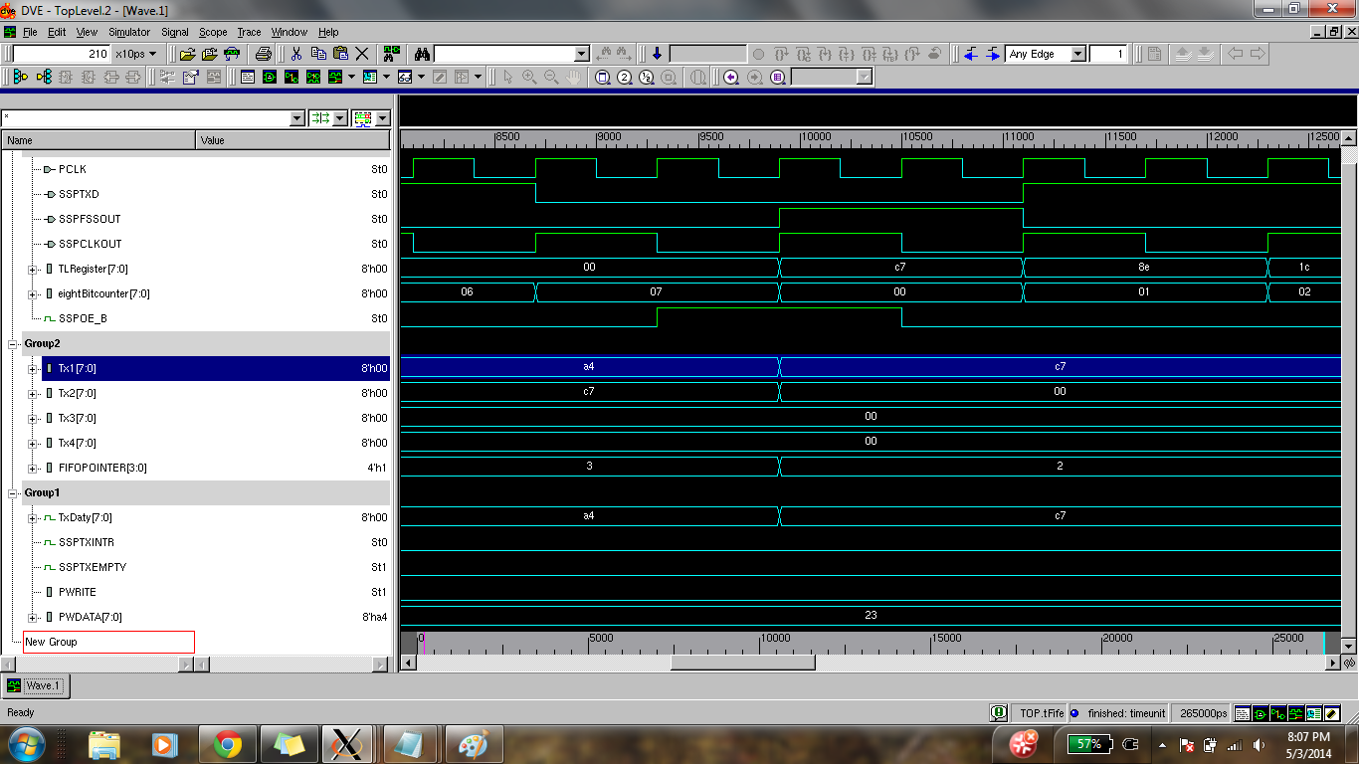

Receiver Results:

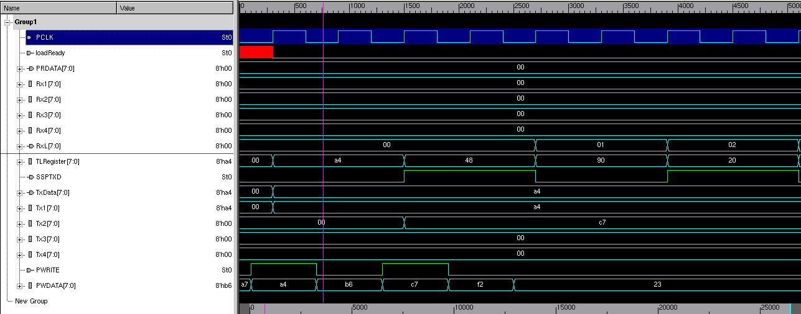

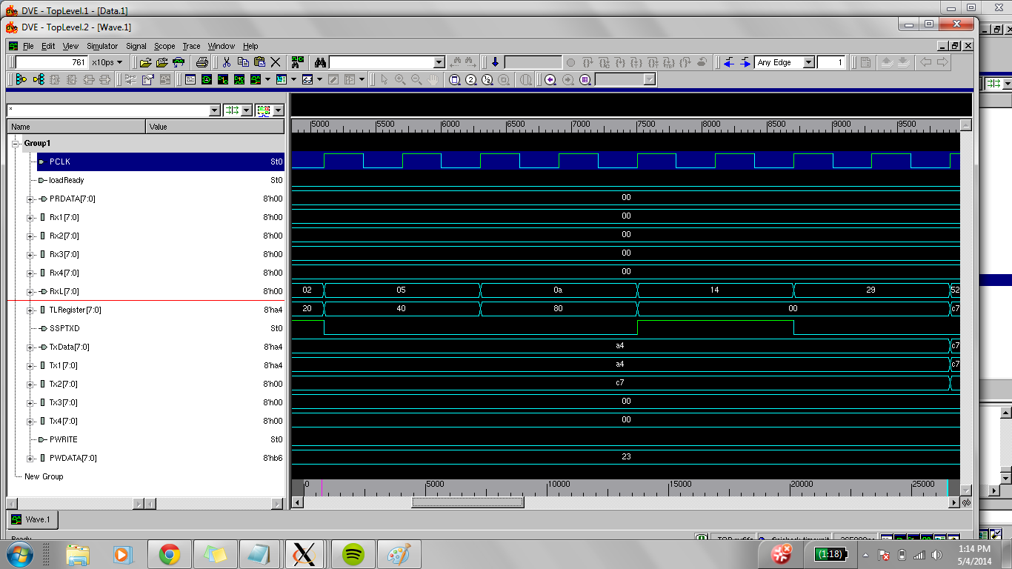

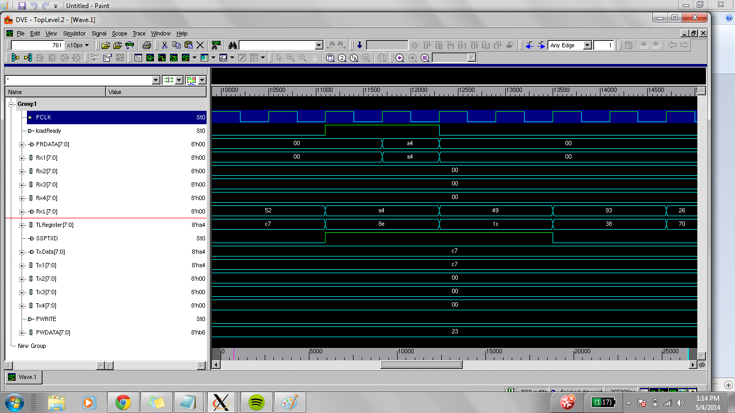

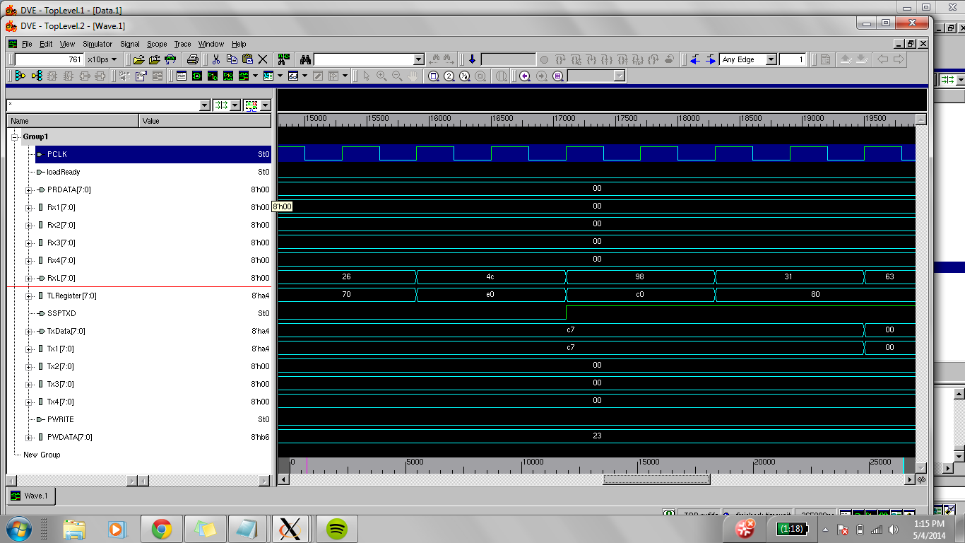

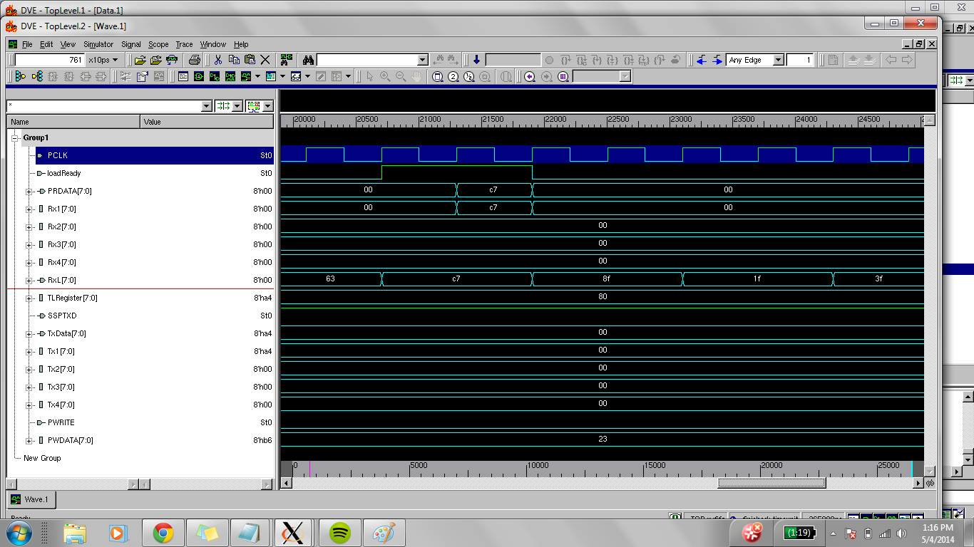

Clear results:
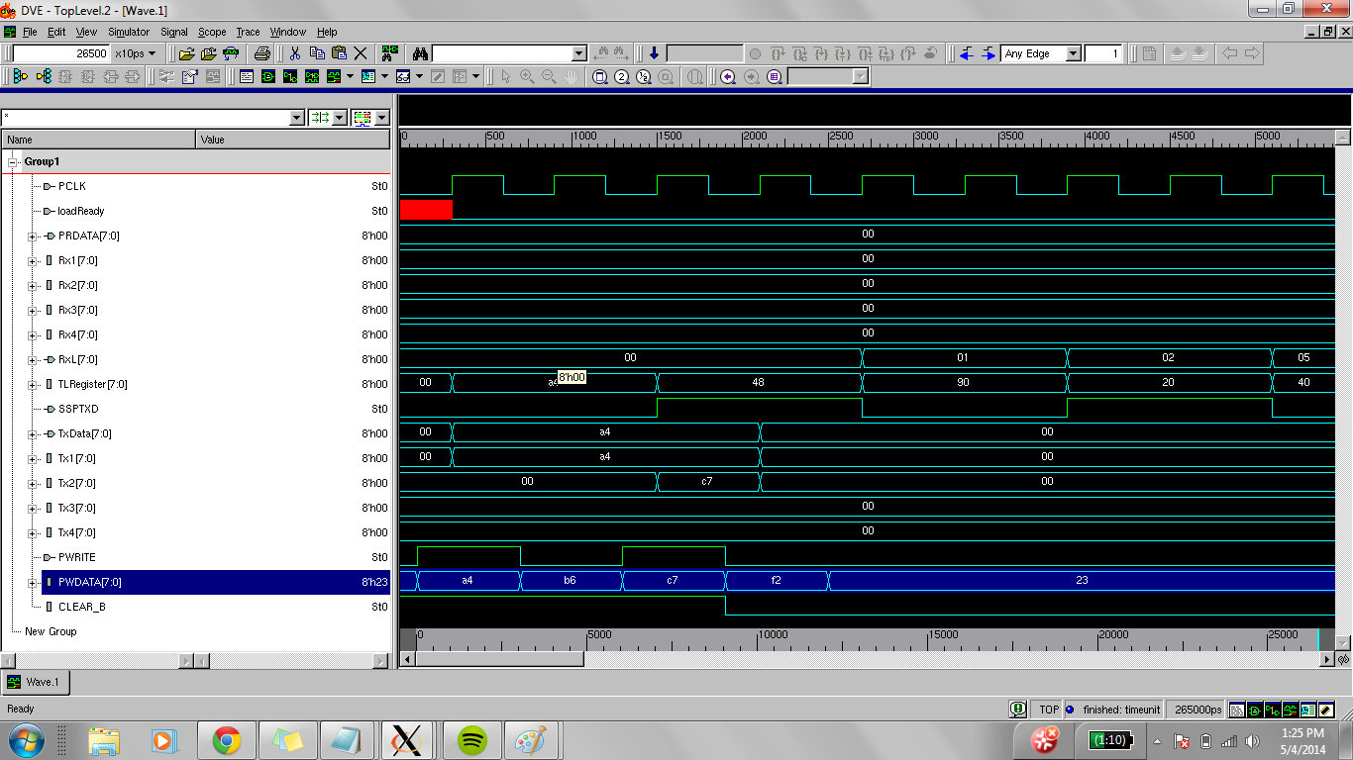

Schematic:
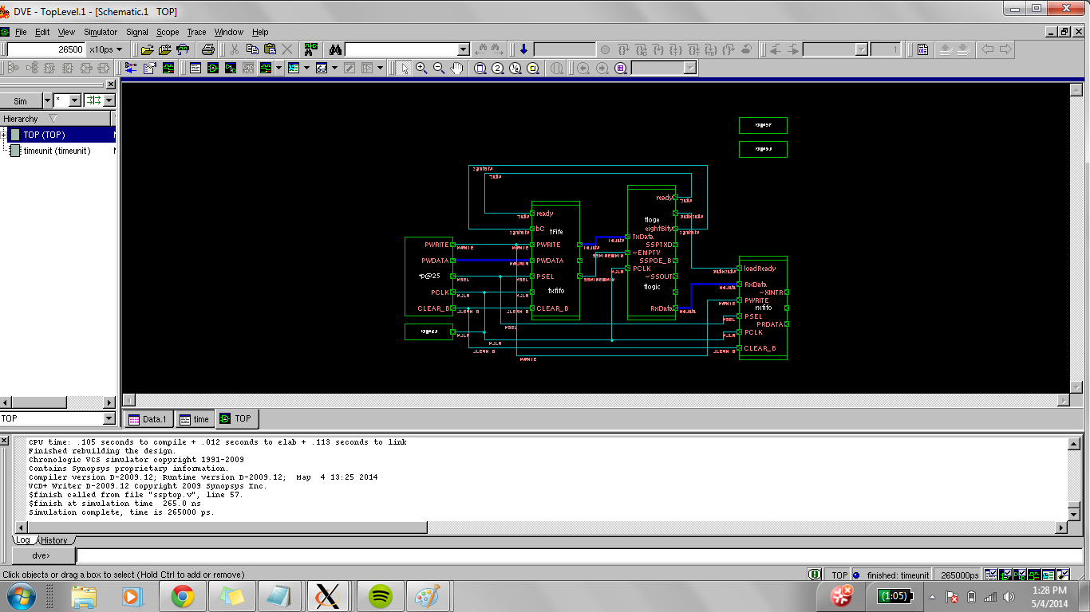

Compiled Design:
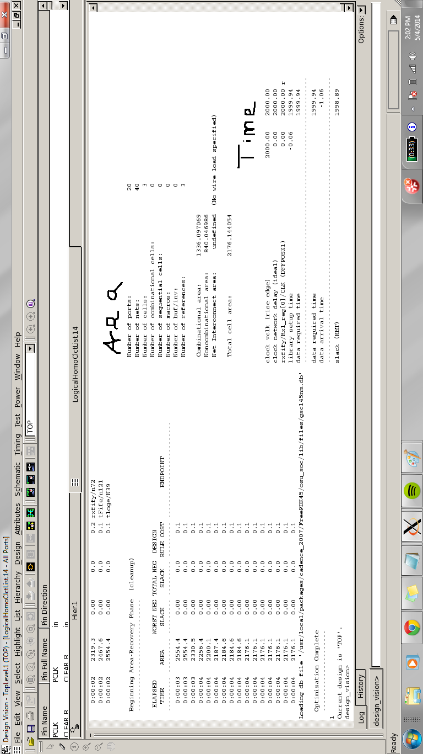
Optimized Design:

